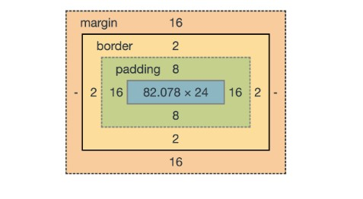

1. If you don’t make any customizations, the size of the box is determined by the content of the element.